**HR-BOT : A RECRUITMENT CHATBOT**

**The project is live on the URL**

http://ec2-13-234-38-210.ap-south-1.compute.amazonaws.com:8080/

**Abstract:**

The growing need of machine learning and AI can effectively be applied to the recruitment process to ease the human life and make the process more cost effective, quick and unbiased. As the recruitment process is being perplexed day by day, sometimes it becomes really tough for a company to go through the all the entire resumes manually and shortlist the candidates based on company requirements for personal interviews. Eventually companies sometimes hire agencies to do this, and end up spending a huge amount of time and money. Here the interview chatbots come into play.

We are building the **HR-BOT** to **automate the initial screening process by chatting with the candidates online and asking relevant questions so that a company can spend less time going through thousands of resumes and shortlist them faster**. It’s not possible for human recruiters to work 24/7 while a chatbot can serve the queries and effectively takes interviews of several candidates at a time without asking for a leave.

**What is Chatbot?**

A chatbot is an intelligent piece of software that is capable of communicating and performing actions similar to a human. Chatbots are used a lot in customer interaction, marketing on social network sites and instantly messaging the client. There are two basic types of chatbot models based on how they are built; Retrieval based and Generative based models.

1. Retrieval based Chatbots: A retrieval-based chatbot uses predefined input patterns and responses. It then uses some type of heuristic approach to select the appropriate response. It is widely used in the industry to make goal-oriented chatbots where we can customize the tone and flow of the chatbot to drive our customers with the best experience.

#### 2. Generative based Chatbots: Generative models are not based on some predefined responses.They are based on seq 2 seq neural networks. It is the same idea as machine translation. In machine translation, we translate the source code from one language to another language but here, we are going to transform input into an output. It needs a large amount of data and it is based on Deep Neural networks.

**Methodology:**

The basic training tools that will be used are:

- Python 3

- Natural Language Processing Tool-kit (nltk)

- Tensorflow 1.15

- Tflearn

* We have used Flask framework to create the web api.
* We are using tflearn(a wrapper above tensorflow) to create this chatbot. .
* The language which we used primarily is python3.
* To create the application interface, we have used HTML and CSS.
* To create the database, we have used PostgreSQL.

PREPROCESSING THE DATA: For training the model we have created a .JSON file(i.e the intents file) containing a bunch of messages related to interview purpose that the user is likely to type and mapped them to a group of appropriate responses.

With this data we will be training a neural network to take the words in a sentence and classify it as one of the tags in our file.

Then simply one response from this tag will be shown to the user as a reply.

This in short describes the context/concept of the query and provides answers accordingly.

**The golden rule here applies, more data, better results.**

We have also used the concepts of Natural Language Processing like word stemming, word tokenizing and creating bag_of_words to make our “HR-BOT” more accurate in finding general meaning behind the question asked.

DEVELOPING AND TRAINING THE MODEL:

We will be using tensorflow deep neural networks with 2 hidden layers. The goal of our network will be to look at a bag of words and give a class that they belong to.

After setting up the model, we will fit the data to our model, defining the number of epochs.

MAKING PREDICTIONS:

Ideally we want to generate a response to any sentence the user types in . To do this, during the actual execution of our “HR-BOT” the process to generate a response will look like the following:-

Get some input from the user ➤ Convert it to a bag of words ➤ Get a prediction from our model ➤ Find the most probable class ➤ Pick a response from that class ➤ Show as response.

**Storing the data of the candidate and sending confirmation email:**

Record the received answers of the user during the interview in a Database ➤ Relate the answers with the criteria of the organization and assign points accordingly to various fields like skills, experience, projects etc. ➤ Send an confirmation email to the candidate containing all the points that he has received in several fields after the chat is over.

This is the overall methodology we will be following for our “HR-BOT” .

DEPLOYMENT: We have deployed our Web-Application on **AWS ec2 instance** .

Wbsite Url: <http://ec2-13-234-38-210.ap-south-1.compute.amazonaws.com:8080/>

**Workflow of how the chatbot respond:**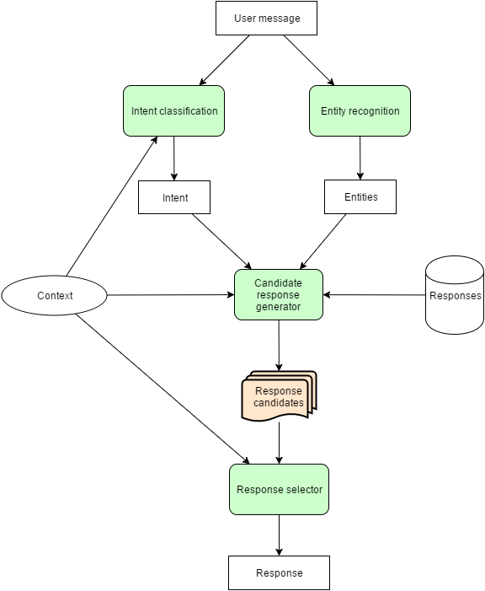

**The entire workflow of assigning points to candidate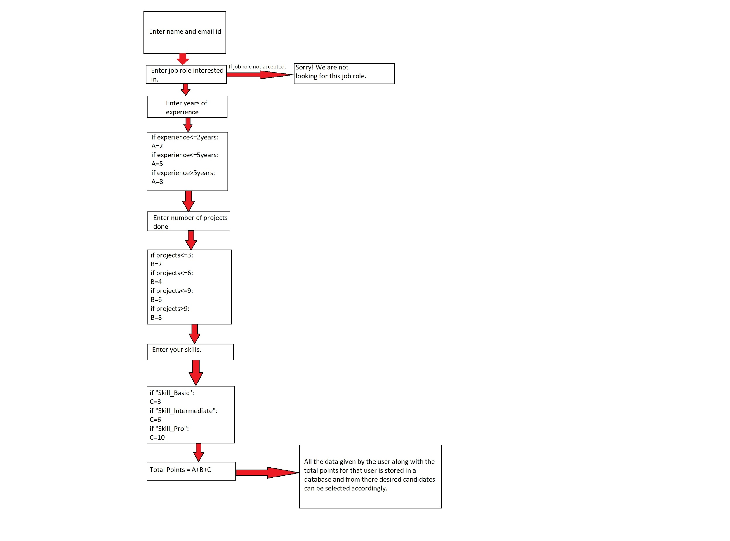:**

**Running the Application:**

In our project, all the credentials of the database and the code solution are provided in the file **aws_credentials .txt** inside the folder **imp.**

**Visit the site at:**

**http://ec2-13-234-38-210.ap-south-1.compute.amazonaws.com:8080/**

Just download the zip file from the our website by clicking on **“Download Code as Zip”** and extract it.

With pip install all the dependancies kept in requirements.txt.

**1. Training The Model**

Run the ‘**HR_Trained_Bot.py**’ file.(optional, as we’ve trained it already)

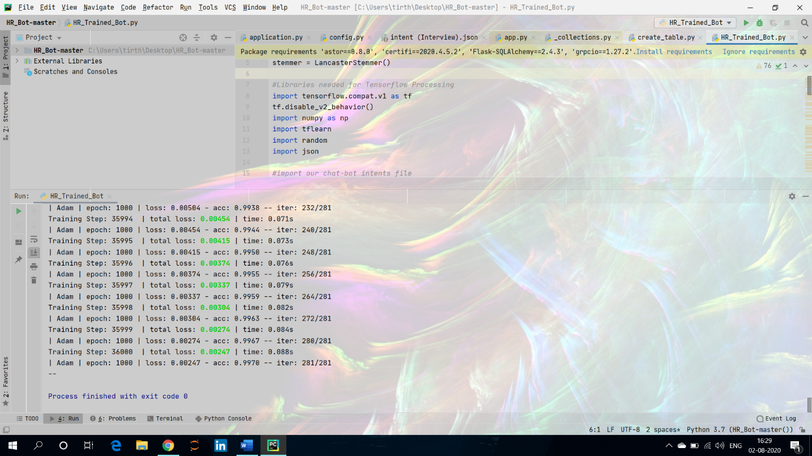

**2. Creating Database On AWS.**

We created a database using AWS RDS posgresql service.

Then we ran the ‘**create_table.py**’ file, that imports ‘**table.py**’ and creates **“scores”** tablein PostgreSQL server database.

**3. Running The Main Application ChatBot**

Run the ‘**application.py**’ file, it is

Eg1 :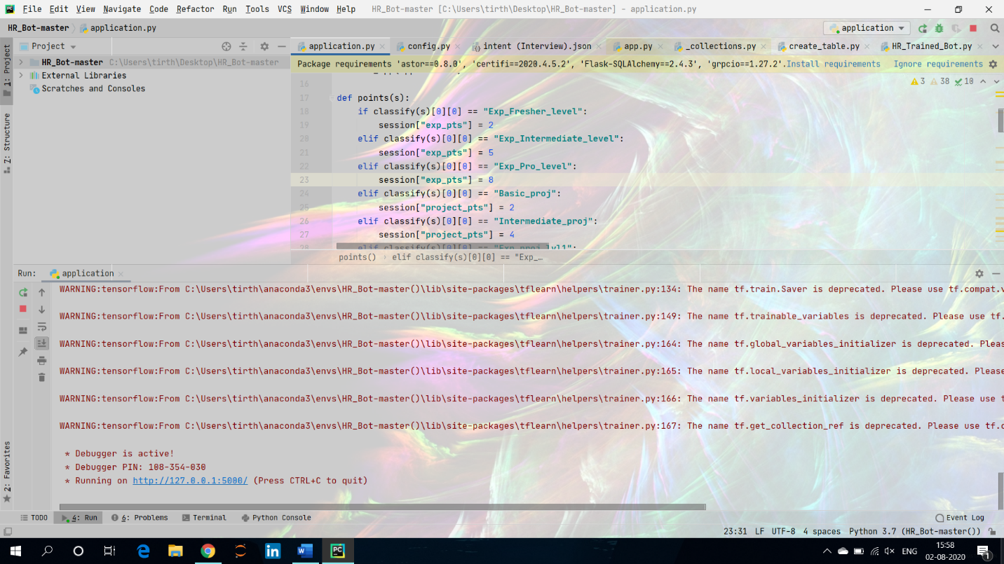

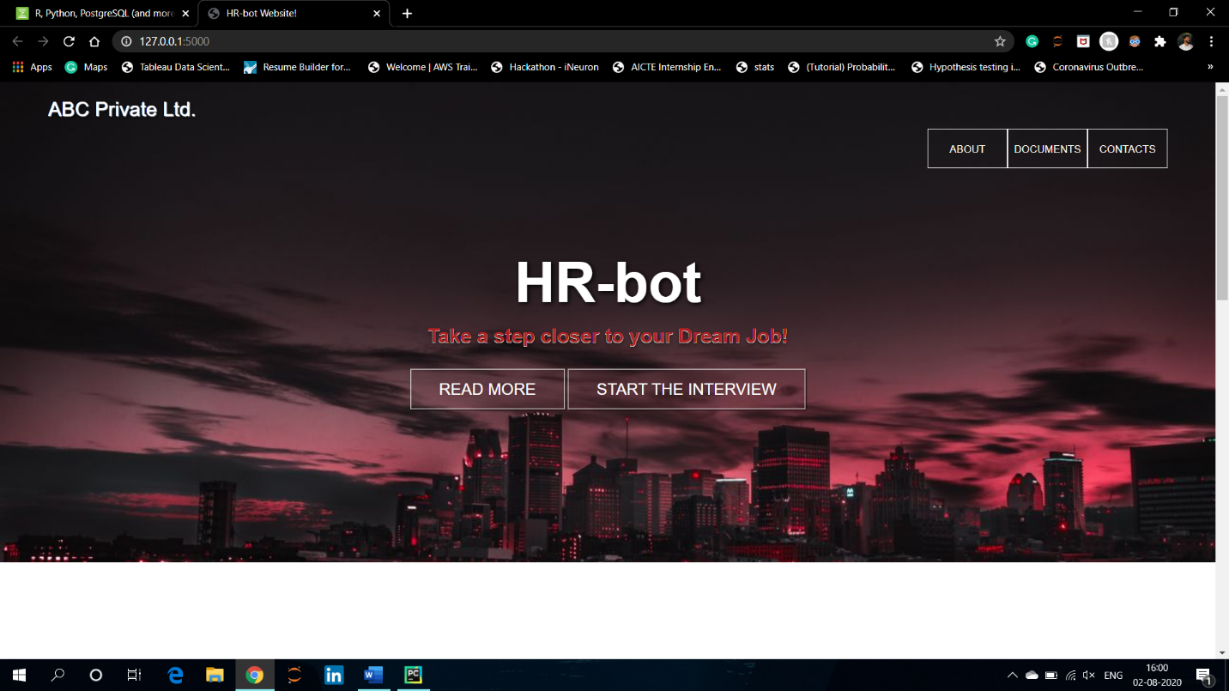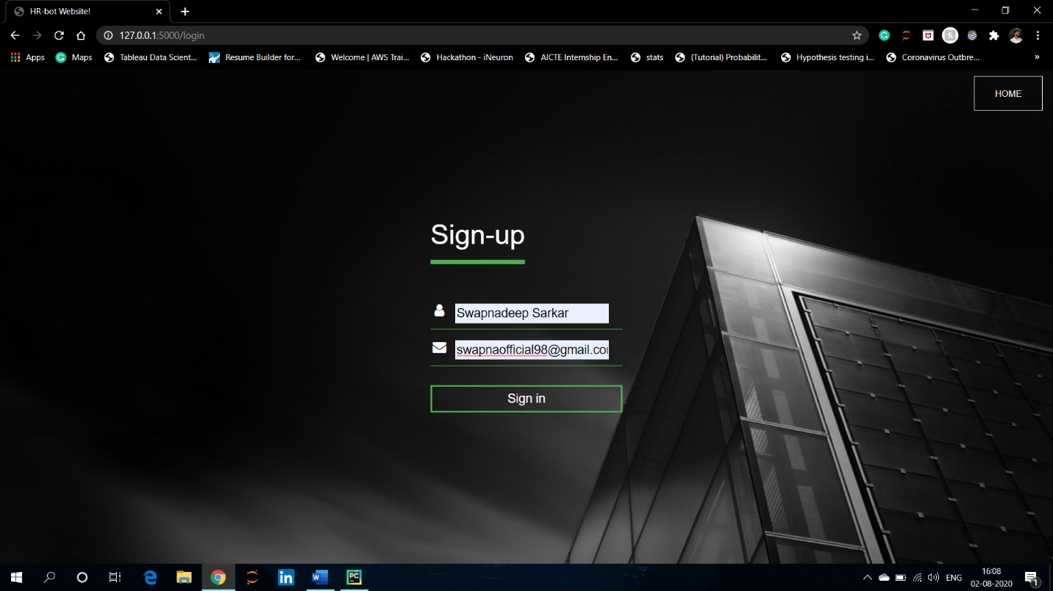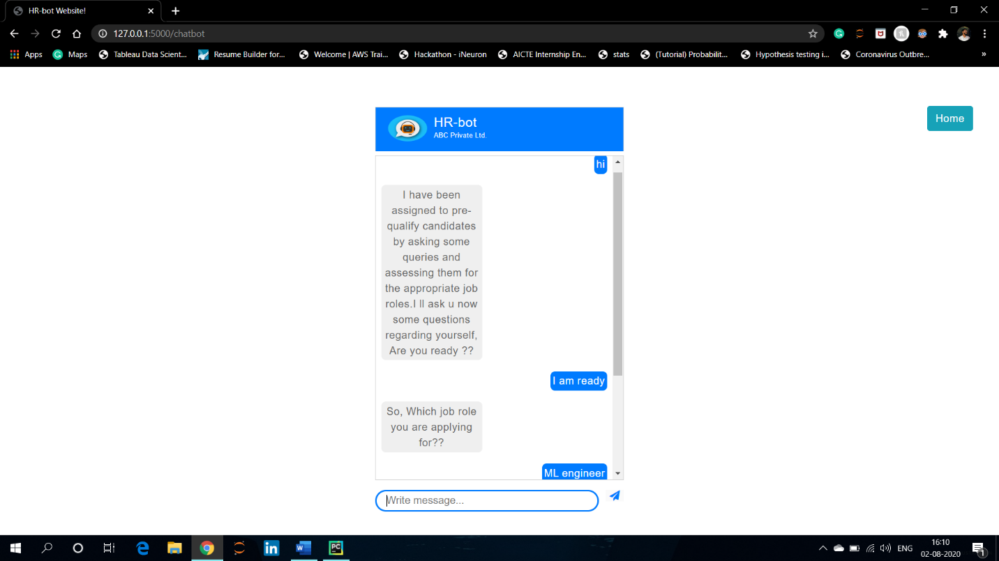

The application asks several questions as shown above, and evaluates accordingly and after exiting it stores your details in the database

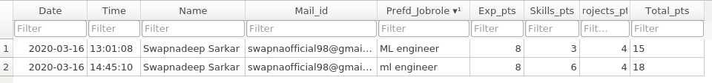The above conversation resulted the 2nd entry in the data base.

Eg 2: Another conversation:

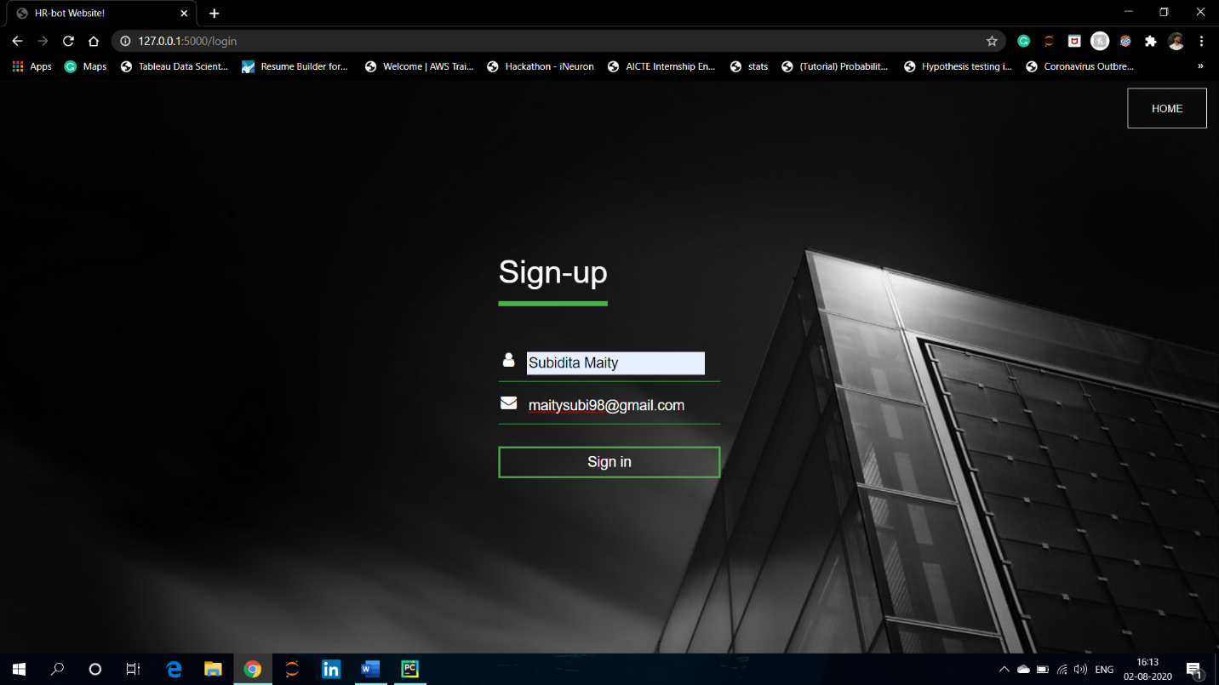

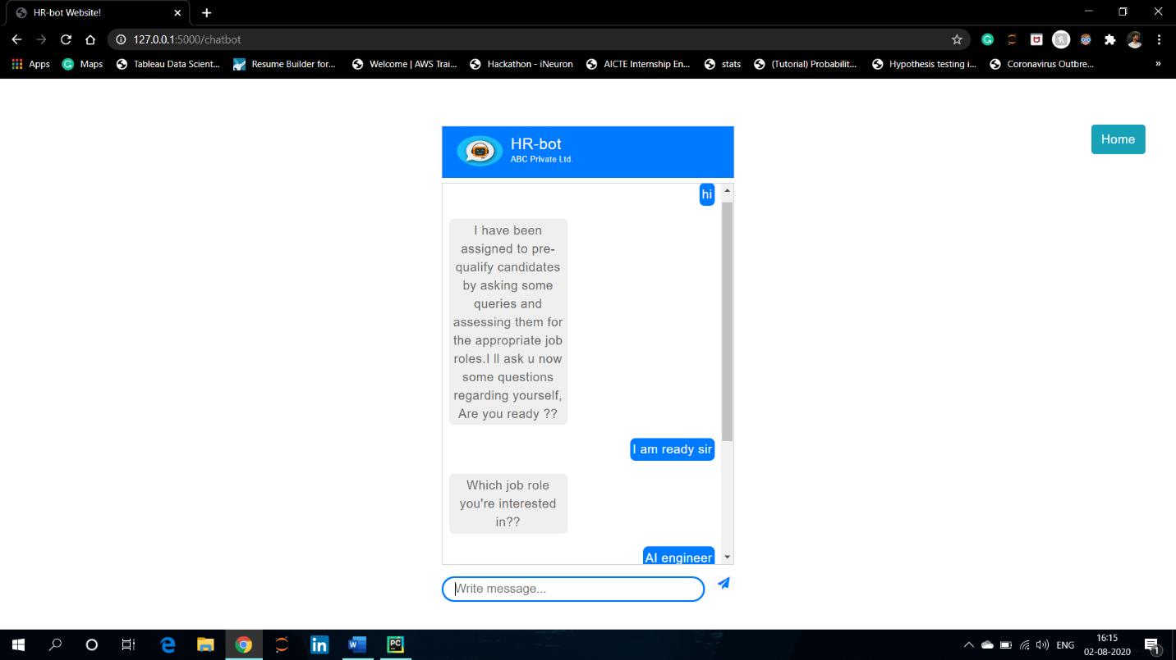

And the table gets updated as follows.

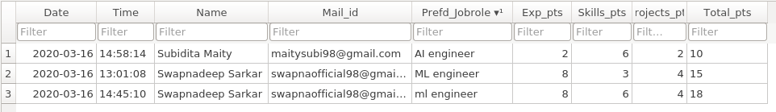

Eg 3: Another candidate:

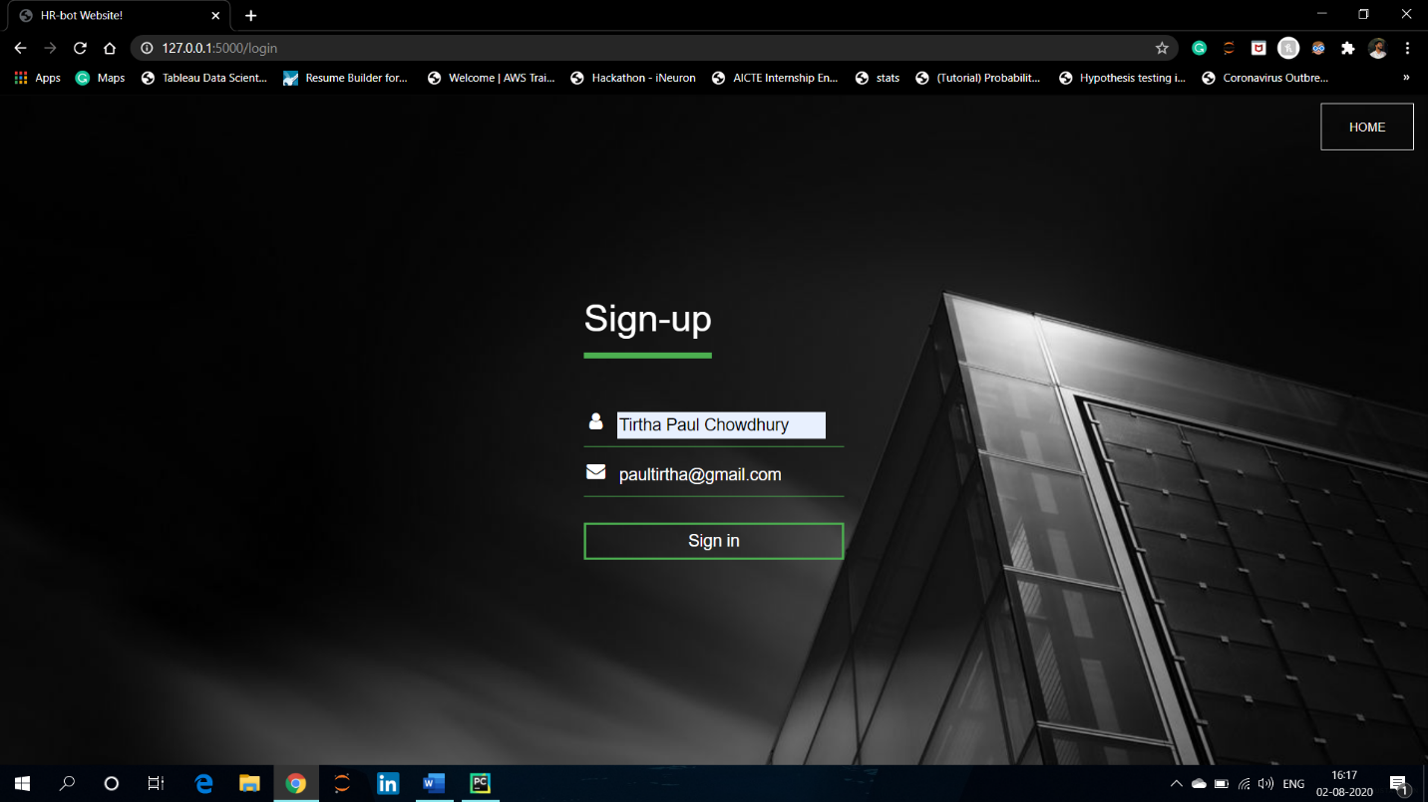

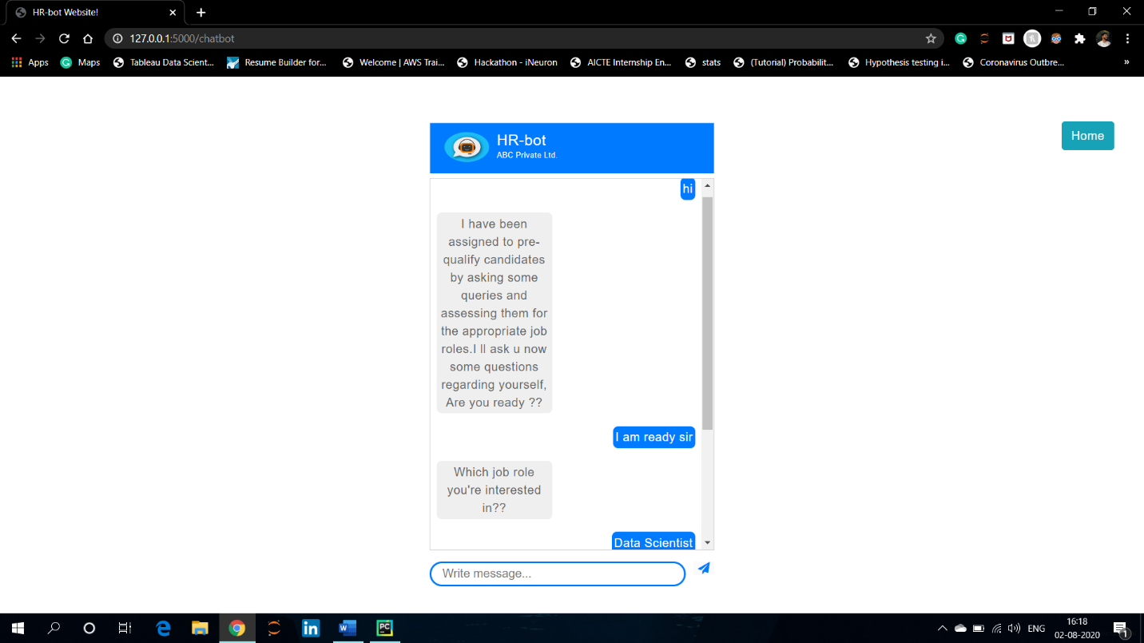

And the table gets updated :

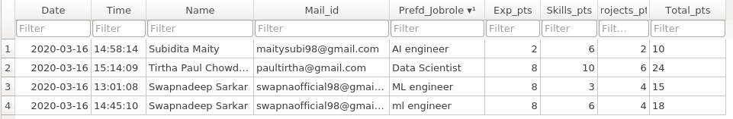

After completing the chat when the candidate will type exit, an automatically generated confirmation mail will be sent to the candidate’s provided email id containing the points that he has got in each field.

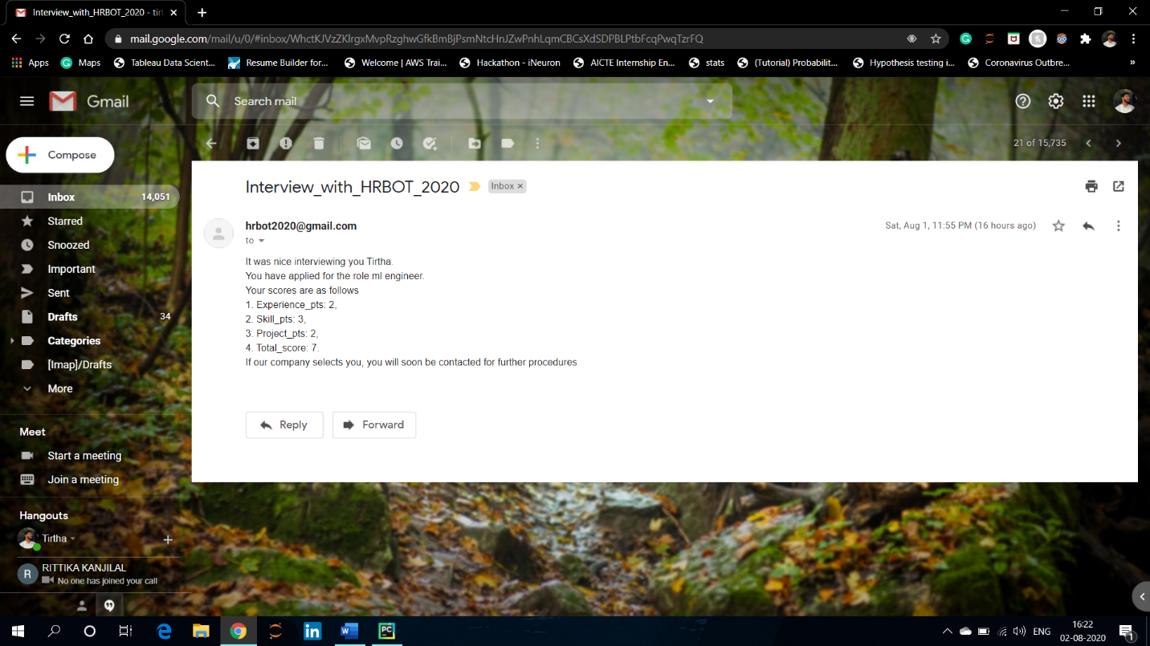

**Application:**

The *points table* created as shown above can be used to shortlist candidates automatically without going through tens of thousands of resumes. Based upon company’s requirements and vaccancies(say 20 seats vaccancy), the company can retrieve top performing candidates (say Top 20) data and can invite them for personal interview.

And even they can select candudates categorically as fresher, intermediate and experienced just by performing some simple SQL operations ( *say, for selecting only freshers, SELECT the top candidates having experience points ‘2’, as 2 point was assigned for freshers*).

The advantages and further scope of works are as follows:

1. **Scheduling Human Interviews:**  Chatbots can assist in automatically scheduling personal interviews or skype calls between the candidates and the recruiters efficiently.

2. **Informing Candidates:** Chatbots are appropriate to inform the candidates about their selection or next steps in the Process.

3. **Familiar Interfaces:** Chatbots are accessible on familiar interfaces so that candidates can deal with the pre- interview sessions at the comfort of home.

4. **Availability:** Chatbots can provide the interview and query session anytime preferable to the candidates. So it’s convenient to automate the interview session.

5. **Unbiased Selection:** Chatbots are software programs so don’t judge anyone on the basis of their appearance, thus making the selection process more unbiased and speedy.

Apart from the aforementioned applications chatbots also work as a mediator between candidates and human recruiters which makes the process more convenient from both the way. It’s a smarter way to handle the huge amount of job applicants by applying the Machine Learning and Deep Learning which helps in saving time and money.

____________